TO BE ADDED AFTER THE LATEST CONTENT IN SECTION 3.5

Moreover, just as the expansive and increasing record of litigation against the tobacco industry has forced tobacco manufacturers themselves to recognize the dangers associated with their products, and has put them increasingly on the defensive, a similar shift is evident with respect to the fossil fuel industry over the past thirty years. For instance, it is now generally understood and accepted that “the oil industry is one of the most powerful and global business sectors today and its activities and products are directly linked with rising greenhouse gas emissions” **FOOTNOTE 1.** In light of the growing recognition of this fact on behalf of the general public,the fossil fuel industry has had to shift their public positioning on the issue from emphasizing the supposed dubiousness of human-induced climate change to affirming scientific consensus on its validity and acknowledging that GHG levels must be reduced.

For instance, the subject of climate change began to be seriously considered by fuel companies such as ExxonMobil, Shell, BP, and others, as early as the 1980s **FOOTNOTE 2.** In these early years, the general approach of the industry towards addressing climate change, enacted through various bodies representing the interest of fossil fuel companies such the Global Climate Coalition (GCC) and the American Petroleum Institute (API), rested on two central strategies: i) undermining climate science; ii) targeting climate-related policy from an economic standpoint in order to undermine governmental action on the issue **FOOTNOTE 3**. These strategies were made explicit in an internal API memo that was leaked to the public in 1998, which stated that the industry must continue “raising questions about and undercutting the prevailing scientific wisdom” around global climate change, because, “unless ‘climate change’ becomes a non-issue, meaning that the Kyoto protocol is defeated and there are no further initiatives to thwart the threat of climate change, there may be no moment when we can declare victory for our efforts” **FOOTNOTE 4.** Similarly, A 1997 annual report for the Competitive Enterprise Institute (CEI), whose known corporate funders include ExxonMobil and the American Petroleum institute, stated that, "As the United Nations prepared for an international conference in Kyoto, Japan to craft an international treaty to suppress the use of fossil fuel energy, CEI's work demonstrated why people have more to fear from global warming policies than from global warming itself." **FOONOTE 5**

At the turn of the century, with scientific evidence of the reality of climate change mounting, members of the API pursued strategies to challenge climate science whilst simultaneously making public announcements acknowledging the potentially long-term consequences of climate change. For instance, in 1999 Brian Flannery, a top climate advisor for ExxonMobil, asserted that,“Exxon does not believe that uncertainty is an excuse for doing nothing. We acknowledge that global climate change is a legitimate concern and we are taking steps now that we believe will lead in the right direction” (Flannery, 1999). Two years earlier, BP Chief Executive John Browne made the following statement in a well-publicized speech at Standford University:“We must now focus on what can and what should be done, not because we can be certain climate change is happening, but because the possibility can’t be ignored. If we are all to take responsibility for the future of our planet, then it falls to us to begin to take precautionary action now.”Moreover, in the same year, Philippe Jaffré, the CEO of Elf Aquitaine, declared in an interview that his company was going to “commit to a reduction of 15% of its CO2 emissions in 2010” based on “the consensus within the scientific community” that, as Jaffré admits, had since been becoming “stronger and stronger in affirming that a climatic warming is happening” **FOOTNOTE 6**. In this same statement, Jaffré goes on to confirm that, “A number of facts are not disputable. First there is a rise in greenhouse gas concentrations, in particular carbon dioxide CO2. Second, these gases have an effect on the climate” **FOOTNOTE 7.**

As these statements show, public acknowledgement about the dangers of climate change became universal by the fossil fuel industry as the new millennium began. However, over the course of the following decade the promise of Big Oil’s commitments to tackle climate change failed to bear much fruit.For instance,the passing of the Kyoto protocol just months after Jaffré’s announcement declaring Elf Aquitaine’s 15% reduction of emissions by 2010, seemed to nullify this commitment. As stated by Bernard Tramier, the company’s Senior VP of Environment and Industrial Safety at the time, the 15% reduction promise “was a commitment taken before Kyoto” and thus it was, “more difficult for us to comply with it after [what happened in] Kyoto” **FOONOTE 8.** Tramier also admitted that the company decided that targets for lowering emissions would not be determined internally, but the company would wait until “the rules of the game—in particular the accounting rules” would be imposed upon them **FOOTNOTE 9**. Also, whileRoyal Dutch Shell was investing energies in developing green technologies throughout the 90s, remaining for a short time the second largest manufacturer of solar panels in the world, in recent years, even as the urgency of the climate problem has mounted, the company has all but abandoned its commitment to developing the renewable energy sector. For instance, in spring of 2009, the company declared that, "[Shell will no longer invest in renewable technologies](http://www.guardian.co.uk/environment/2009/mar/21/renewable-energy-economic-crisis) such as wind, solar and hydropower because they are not economic" **FOOTNOTE 10** Similarly, throughout the late 90s and early 2000s, BP were often touted as the most progressive company on the issue of climate change; however, their “proactive approach” to climate change has emerged as ultimately unsubstantiated **FOOTNOTE 11**. For instance, as described in *Section 7.6 Don’t fossil fuel companies invest in renewable energies?*BP has deserted its solar and wind energy projects, and has since committed over $1 billion dollars over the next few years in arctic drilling projects and in companies with activities exploiting the Alberta oil sands. Moreover, the 2010 oil spill along the Gulf of Mexico did extensive damage to the BP “Beyond Petroleum” brand image due to the massive volume of the spill (over 4 million barrels) and resulting damage, which included the deaths of 11 rig workers and wide-ranging environmental harm. In the aftermath of the spill, hundreds of lawsuits were filed against the company, including one pending case brought against BP by the government, business and individuals charging the company with gross negligence. **FOOTNOTE 12**

ExxonMobil holds the greatest legacy when it comes to failing to address the recognized harms of rising GHG emissions and resultant climate change. For instance, since the 1990s ExxonMobil has provided millions of dollars to the organizations and think tanks that have worked to undermine climate science **FOOTNOTE 13** **FOOTNOTE 14***.* Similarly, in 2003, an email leaked to the public by Greenpeace claimed that the Exxon-support CEI worked with representatives from the White House to undermine the EPA’s attempts at tackling climate change **FOOTNOTE 15.** According to Richard Blumenthal, State Attorney General of Connecticut, and G. Steven Rowe, State Attorney General of Maine, the email obtained by Greenpeace "reveals great intimacy between CEI and [Bush Administration official Cooney] in their strategizing about ways to minimize the problem of global warming. It also suggests that CEQ [the Council of Environmental Quality] may have been directly involved in efforts to undermine the United States' official reports, as well as the authority of the EPA Administrator**.” FOOTNOTE 16.**

The company’s conduct remained so offensive that in 2006 the UK Royal Society wrote a letter to Nick Thomas, then Director of Corporate Affairs for ExxonMobil, denouncing the company’s attempts at undermining the latest IPCC report and asking that the company stop funding organizations that “misinformed the public about climate change through their websites” **FOOTNOTE 17.** Just a year later, the Exxon-supported American Enterprise Institute (AEI)—whose board of trustees includes past CEO of ExxonMobil Lee Raymond, pledged to scientists and economists a sum of thousands of dollars to discredit the findings reported in the latest IPCC study and produce articles highlighting the limitations of this report. **FOOTNOTE 18.** In an outraged response, David Viner of the Climatic Research Unit at the University of East Anglia declared that this move represented “a desperate attempt by an organization who wants to distort science for their own political aims” **FOOTNOTE 19.** Exxon’s continued advocacy of climate denial compelled the Union of Concerned Scientist (UCS) to issue a report in 2007 entitled “*Smoke, Mirrors & Hot Air: How ExxonMobil Uses Big Tobacco’s Tactics to Manufacture Uncertainty on Climate Science*. In this report, the USC declares that “ExxonMobil has played the world’s most active corporate role in underwriting efforts to thwart and undermine climate change regulation” **FOOTNOTE 20**, likening Exxon’s efforts to a Big Tobacco-style PR campaign geared towards misinforming the public on climate science **FOOTNOTE 21**. Such attempts to dissuade the company from undermining scientific evidence appeared to be in vain, as Exxon was again directly implicated in funding climate deniers in 2011. This time, Exxon was found to be involved in funding research showcased on the Global Warming Policy Foundation’s (GWPF) website, which released a survey of over 900 articles downplaying the urgency of climate change under the headline “900+ Peer-Reviewed Papers Supporting Skepticism Of ‘Man-Made’ Global Warming (AGW) Alarm” **FOOTNOTE 22**. On their website, the GWPF described these articles as contesting the “concern relating to a negative environmental or socio-economic effect of AGW, usually exaggerated as catastrophic.” Investigation by the Carbon Brief found that nine of the ten authors that contributed the most papers in the survey have links to organizations that are funded by ExxonMobil, while the tenth was co-author on several papers that included Exxon-funded contributors **FOOTNOTE 23.**

Thus, while fossil fuel companies have been publicly acknowledging the harmful effects of their primary activities and products the 1980s, they have also simultaneously exhibited “socially harmful” behaviour by: i.) taking decisive action to undermine climate science; ii.) exerting influence to stall or inhibit public policy related to combating climate change; iii.) neglecting or abandoning projects dedicated to contributing to a renewable and sustainable energy infrastructure; iv.) and ramping up projects to extract even more fossil fuels by exploiting unconventional sources (e.g. the Alberta oil sands or arctic drilling projects)—all while possessing the knowledge that continuing to increase GHG emissions will exacerbate dangerous climate change.

**Examples of oil industry “greenwashing”**

“Greenwashing” describes advertisements and communications that claim that the featured products or companies are environmentally friendly when in fact they serve to exacerbate environmental problems in one way or another—predominately in ways that remain obscure for the average consumer **FOOTNOTE 24.** “Greenwashing” helps to create a positive brand image for oil companies and also works to obscure the harmful effects of their operations to the public. This tactic has precedent in the activities of tobacco companies, who poured extensive amounts of money in advertising and PR campaigns to help improve their corporate image **FOOTNOTE 25.** (Take, for instance, Philip Morris Companies, who for years positioned themselves as one of the [biggest benefactors](http://www.kentuckycrafts.org/pm.html) of the arts and culture whilst avoiding anything related to healthcare **FOOTNOTE 26**). “Greenwashing” is evident in many of the biggest ad campaigns promoted by the fossil fuel industry’s major players in recent years.

The following section highlights some examples of oil industry “greenwashing” in order to advance two specific objectives: first, to show that the industry overtly acknowledge the harm their products and activities cause to the planet; and secondly to emphasize the inadequacies and shortfalls of oil companies’ plans to redress the harm caused by their operations in the form of extracting and burning fossil fuels.

**Examples of oil industry “greenwashing”**

1.) BP – “Making It Right” PR campaign:

After the Gulf of Mexico oil spill in the spring of 2010, BP undertook an extensive PR campaign to restore the company’s tarnished image. The “Making it Right” campaign highlighted seven different areas in which the company committed funds and resources in efforts at mitigating and repairing the damage done by the spill, including beaches, general cleanup, economic investment, insurance claims, environmental restoration, health and safety and wildlife (see Figures A & B). In their series of print ads that comprised one component of this campaign, a statement on an image showing a group of people cleaning a shoreline along the Gulf reads: “We may not always be perfect, but we will make this right.” BP spared no expense in pushing this campaign after the disaster—spending up to $5 million a week on ads. The company estimated a sum of $93 million was spend on ads from April to July during the course of the 87 day oil spill, which the company claimed were published to keep area residents informed on progress **FOOTNOTE 27.** Other sources allege much more was spent on PR. For instance, investigators at Greenpeace UK found that the company spent approximately $5.6 billion dollars in a single month advertising in 3 popular magazines **FOOTNOTE 28.**

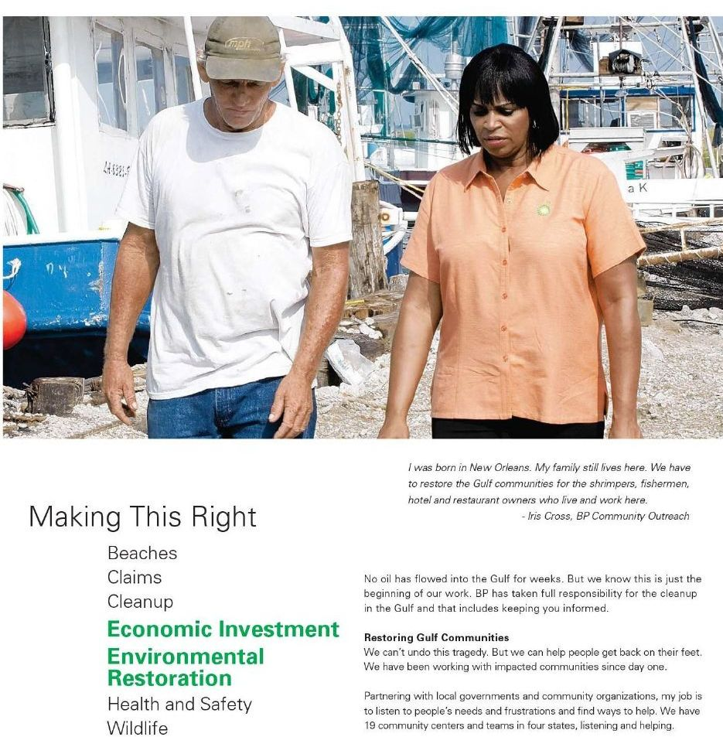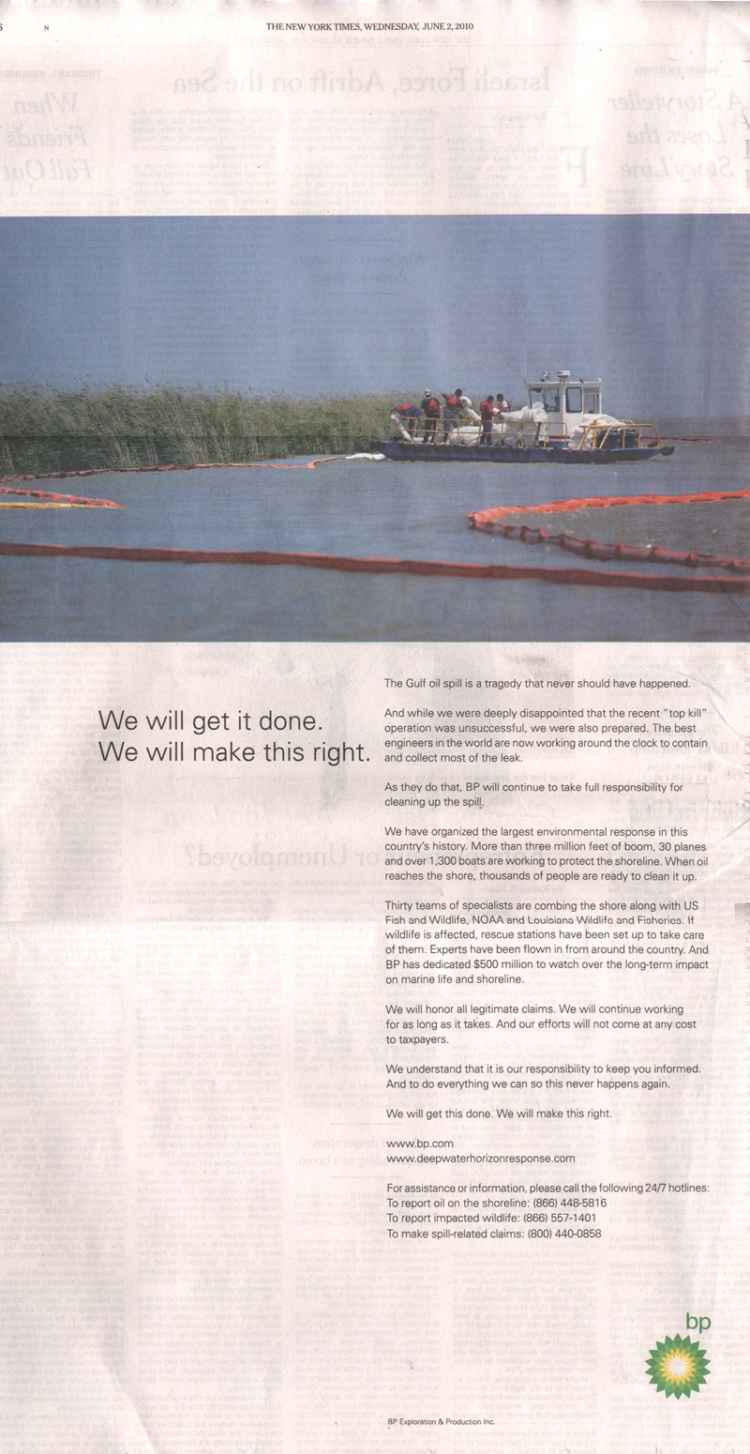Figure A. BP “Making Ths Right” newsprint ad. Figure B. BP “Making This Right” ad

**2.) SHELL “Let’s go” and “New Energy Future” advertising campaigns:**

a.) *Let’s Go! Campaign:* In recent years Shell has undertaken a series of marketing campaigns aimed at positioning the company as environmentally friendly. In 2010, JWT London launched the Shell “Let’s Go” campaign advertised the company’s efforts at pursuing innovative energy solutions to help “broaden the world’ energy mix” for the next generation. **FOOTNOTE 29.** The campaign is explained on its US website follows: “Energy use around the world is rising, as global population grows and more people gain access to modern energy. At Shell we believe a broad energy mix will be needed to help meet demand and limit CO2 emissions. We’re finding ways to deliver energy from cleaner sources and make the most of existing resources.” As Samples of the series of ads are featured on the site, and can also be seen in Figures C and D below.



Figure C. Shell “Let’s Go” ad



Figure D. Shell “Let’s Go” ad.

As evident in these ads, Shell itself is advertising the need to branch away from fossil fuels and showcasing its apparent efforts at advancing the development of new energies.

b.) *New Energy Future Campaign:* The “Let’s Go” campaign follows an earlier effort on behalf of the company to promote innovative energy solutions as a means of dealing with the climate problem, as seen in their “New Energy Future” ads **FOONOTE 30**. For instance, a Shell advertisement featured in a December 8, 2008 issue of *Fortune* magazine, declares Shell’s supposed commitment to addressing climate change (see Figure E). The ad reads:

*“Tackling climate change and providing fuel for a growing population seems like an impossible problem, but at Shell we try to think creatively. In addition to our growing oil and gas business, we’re investing in energy sources like wind, and also investigating innovative new engine fuels made from unexpected sources like gas, hydrogen, straw, waste woodchips, and marine algae. It won’t be easy. Innovative solutions rarely are. But when the challenge is hardest, when everyone else is shaking their heads, we believe there is a way. To find out how Shell is helping to prepare for the new energy future, visit* [*www.shell.com/us/realenergy*](http://www.shell.com/us/realenergy)*.”*

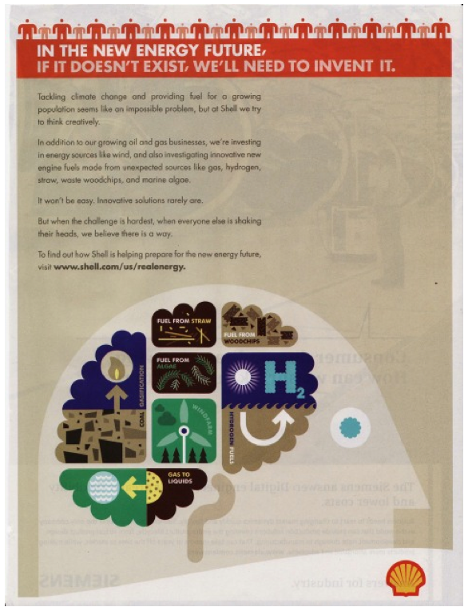

Figure E. Shell “New Energy Future” ad.

Another example of similar advertisements, this time appearing in UK newspapers and magazines, features a full page ad that depicts a series of red shells floating amidst two paragraphs of text that makes another direct reference to climate change (see Figure F). The full text of this ad reads as follows:

*“... we need to find new ways of managing carbon emissions to limit climate change. Continued investment in technology is one of the key ways we are able to address this challenge, and continue to secure a profitable and sustainable future … The challenge of the 21st century is to meet the growing need for energy in ways that are not only profitable but sustainable... In Canada we're harnessing our global network of technical and financial expertise to unlock the potential of the vast Canadian oil sands deposit. In the USA we're helping to build what will be the nation's largest refinery.”*

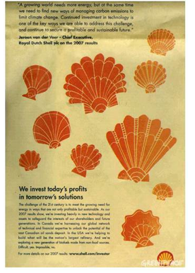

Figure F. Shell “New Energy Future” ad

In accordance with the general argument advanced in this brief, investment in the oil sands represents an initiative that directly contradicts the commitment to finding “new ways of managing carbon emissions to limit climate change". Thus, not only does this ad illustrate Shell’s recognition of the need to limit GHG emissions, but it simultaneously presents false information to the public about the oil sands project, which is actually one of the most environmentally damaging projects on the planet (see relevant section of brief). These points were validated by the UK Advertising Standards Authority in August 2008, as a result of accusations brought against Shell by the World Wildlife Fund (WWF) UK. The WWF UK claimed that Shell was responsible for false advertising with relation to this particular ad, citing violations of the CAP Code on articles 3.1, 7.1, 49.1, and 49.3 that deal with substantiation, truthfulness and environmental claims **FOOTNOTE 31.**

The UK Advertising Standards Authority (ASA) determined that the ad was misleading due to the harmful impacts of the oils sands, stating that “the large scale of the oil sands developments had considerable social and environmental impacts, including those on water conservation, greenhouse gas emissions (GHG), land disturbance and waste management”; the ASA also declared that, “Because we had not seen data that showed how Shell was effectively managing carbon emissions from its oil sands projects in order to limit climate change, we concluded that on this point the ad was misleading” **FOOTNOTE 32**. The ASA ordered that the ad be taken down and not reappear in its current form. Since that time, Shell has continued to publish advertisements with similar misleading and erroneous claims in other parts of the word, including the US ad shown in Figure G that claims “less CO2”. Another advertisement advertising Shell’s so-called effort at “capturing” and limiting carbon emissions appears in a double-page spread on the front cover of *Atlantic* magazine in July, 2009 (see Figure H on next page).



Figure G. Shell “New Energy Future” ad



Figure H. Shell “New Energy Future” ad

One year prior Shell was also found guilty of breaching codes 7.1 (truthfulness) and 49.1 (environmental claims) **FOOTNOTE 33** on another national print ad that stated: “Don’t throw anything away, there is no away” and depicted an oil refinery with flowers emerging from the smoke stacks. Additional text declared, “If only we had a magic bin that we could throw stuff in and make it disappear forever. What we can do is find creative ways to recycle. We use our waste CO2 to grow flowers, and our waste sulphur to make super-strong concrete. Real energy solutions for the real world”.

OTHER EXAMPLES OF RELEVANT “GREEN WASHING”:

A Honda ad (Figure I) in a winter issue of The Atlantic (January 2008) features the following statement: “Higher fuel efficiency, lower greenhouse gas emissions … which means our vehicles have emitted less CO2 -- the primary cause of global warming -- on average, than any other car company.”

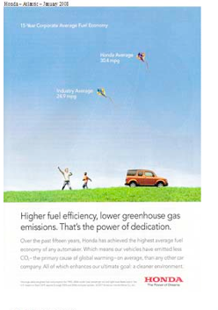

Figure I. Honda advertisement.

ADD TO SECTION LINKING TOBACCO AND FOSSIL FUEL INDUSTRY:

The Union of Concerned Scientists explicitly liken the fossil fuel industry to Big Tobacco in their 2007 report, *Smoke, Mirrors & Hot Air*

*How ExxonMobil Uses Big Tobacco’s Tactics to Manufacture Uncertainty on Climate Science.*

“Exxon (and later ExxonMobil), concerned about potential repercussions for its business, argued from the start that no global warming trend existed and that a link between human activity and climate change could not be established.26 Just as the tobacco companies initially responded with a coalition to address the health effects of smoking, Exxon and the American Petroleum Institute (an organization twice chaired by former Exxon CEO Lee Raymond) joined with other energy, automotive, and industrial companies in 1989 to form the Global Climate Coalition.27 The coalition responded aggressively to the emerging scientific studies about global warming by opposing governmental action designed to address the problem” **FOOTNOTE 34**.

**REFERENCES:**

**FOOTNOTE 1** van den Hove, S. Le Menestrel, M. & de Bettignies, H-C. (2002)The oil industry and climate change: strategies and ethical dilemmas, *Climate Policy* 2, p. 3

**FOOTNOTE 2** In a 2000 interview, Brian Flannery, the Science Strategy and Programs Manager for ExxonMobil’s Safety, Health, and Environment Division, stated that it was “Since the 1980s, [that] we started thinking about climate change as a potentially important issue,” (as qtd. in van den Hove, et al., 2002, p. 4). Similarly, the issue of climate change was first brought up at a meeting of the executive committee of Elf Aquitaine in 1985, after which group began monitoring the scientific and political evolution of global warming (van den Hove et al., 2002, p. 9).

**FOOTNOTE 3** van den Hove, et. al., 2002, p.5

**FOOTNOTE 4** *ibid*, p. 5

**FOOTNOTE 5** Competitive Enterprise Institute (1997). Annual Report.

**FOOTNOTE 6** Jaffré, 1997, as qtd. in van den Hove et. al, 2002,p.9.

**FOOTNOTE 7** *ibid*, p. 9

**FOOTNOTE 8** Tramier, 2001 as qtd. in van den Hove et al., 2002, p. 26

**FOOTNOTE 9***ibid*, 27.

**FOOTNOTE 10** Pearce, Fred. "Greenwash: Shell Betrays 'new Energy Future' Promises." *The Guardian*. N.p., 26 Mar. 2009. Web. Available at: <http://www.guardian.co.uk/environment/2009/mar/26/fred-pearce-greenwash-shell-exxon>

**FOOTNOTE 11** van den Hove, Le Menestrel, & de Bettignies, 2002.

**FOOTNOTE 12** In re Oil Spill by the Oil Rig Deepwater Horizon in the Gulf of Mexico on April 20, 2010, 10-md-02179, U.S. District Court, Eastern District of Louisiana (New Orleans).

**FOOTNOTE 13** Cushman, J., 1998. Industrial Group Plans to Fight Climate Treaty. New York Times, 26 April 1998. Available at http://www.corpwatch.org/trac/feature/climate/culprits/bigoil.html,

**FOOTNOTE 14** See, Center for Responsive Politics, *Oil & gas: Top contributors to federal candidates and parties* (2000), http://www.opensecrets.org/industries/contrib. asp?Ind=E01&Cycle=2000; or, Center for Responsive Politics. Visit http://www.opensecrets.org/lobbyists/index.asp and search for client exxon Mobil. For 1998, search for both exxon Corp and Mobil Oil.

**FOOTNOTE 15** "Greenpeace Obtains Smoking-gun Memo: White House/Exxon Link Conservative Front Group May Have Thanked White House for Help in Suing EPA." *Greenpeace International*. N.p., 9 Sept. 2003. Web. 14 July 2012. Available at: <http://www.greenpeace.org/international/en/news/features/investigation-of-exxon-front-g/> .

**FOOTNOTE 16** ibid.

**FOOTNOTE 17** *The Royal Society*, September 4th, 2006, p. 2. See full letter here: <http://image.guardian.co.uk/sys-files/Guardian/documents/2006/09/19/LettertoNick.pdf> .

**FOOTNOTE 18.** Sample, Ian. "Scientists Offered Cash to Dispute Climate Study." *The Guardian*. Guardian News and Media, 02 Jan. 2007. Web. 15 July 2013.

**FOOTNOTE 19.** *Ibid*

**FOOTNOTE 20** See Union of Concerned Scientists (2007) *Smoke, Mirrors & Hot Air*

*How ExxonMobil Uses Big Tobacco’s Tactics to Manufacture Uncertainty on Climate Science*. Report. See Table 1 *Select ExxonMobil-Funded Organizations Providing Disinformation on Global Warming*, p. 5.

**FOOTNOTE 21** *ibid*, p. 33

**FOOTNOTE 22** "900 Peer-Reviewed Papers Supporting Skepticism Of “Man-Made” Global Warming (AGW) Alarm." *The Global Warming Policy Foundation (GWPF)*. N.p., 14 Apr. 2011. Web. 15 July 2013. Available at: <http://www.thegwpf.org/900-peer-reviewed-papers-supporting-skepticism-of-qman-madeq-global-warming-agw-alarm/>

**FOOTNOTE 23** "Analysing the ‘900 Papers Supporting Climate Scepticism’: 9 out of Top 10 Authors Linked to ExxonMobil." *The Carbon Brief*. N.p., 15 Apr. 2011. Web. 15 July 2013. Available at: <http://www.carbonbrief.org/blog/2011/04/900-papers-supporting-climate-scepticism-exxon-links>

**FOOTNOTE 24** "About Greenwashing | Greenwashing Index." *Greenwashing Index*. N.p., n.d. Web. 15 July 2013 <http://www.greenwashingindex.com/about-greenwashing/>

**FOOTNOTE 25** See Clearway Minnesota. (2010). *Unfiltered, A Revealing Look at Today’s Tobacco Industry*, Full Report. Available at: <http://www.stillaproblem.com/assets/documents/full-report.pdf> or National Cancer Institute (March, 2012). “Smoking and Tobacco Control Monographs; Monograph 19: The Role of the Media in Promoting and Reducing Tobacco Use”, *Tobacco Companies’ Public Relations Efforts: Corporate Sponsorship and Advertising* pp. 179-209. Available at: *<http://cancercontrol.cancer.gov/brp/tcrb/monographs/19/m19_6.pdf>*

**FOOTNOTE 26** Clearway Minnesota, (2012), pp. 14-15

**FOOTNOTE 27** "BP's Been Spending More than $5 Million a Week on Advertising since Oil Spill Birmingham Huntsville Mobile Montgomery Tuscaloosa Anniston/Gadsden Beaches All Alabama." *The Associated Press*. N.p., 1 Sept. 2010. Web. 15 July 2013. Available at: <http://blog.al.com/live/2010/09/bps_been_spending_more_than_5.html> .

**FOOTNOTE 28** Walker, Hayley. "BP Spends $5.6 Million on Advertising in 3 Newspapers in 1 Month."*Greenpeace*. N.p., 30 July 2010. Web. 15 July 2013. Available at: <http://members.greenpeace.org/blog/greenwashing/2010/07/30/bp-spends-5-6-million-on-advertising-in>

**FOOTNOTE 29** Shell Let's Go." *Shell Global*. <http://www.shell.com/global/aboutshell/lets-go-tpkg.html>

**FOOTNOTE 30**Svoboda, Michael. "Advertising Climate Change: A Study of Green Ads, 2005-2010." *Greentech Media*. N.p., 2 Aug. 2011. Web. 15 July 2013.

**FOOTNOTE 31** see ASA Rulings (August 13th, 2008), *ASA Adjunction on Shell International Ltd*. Complaint Reference 50657. See full judgment at: <http://www.asa.org.uk/Rulings/Adjudications/2008/8/Shell-International-Ltd/TF_ADJ_44828.aspx>

**FOOTNOTE 32***, ibid.*

**FOOTNOTE 33** ASA Rulings (November 7th, 2007), *ASA Adjunction on Shell International Ltd*. Complaint Reference 33778. See full judgment at: <http://www.asa.org.uk/Rulings/Adjudications/2007/11/Shell-Europe-Oil-Products-Ltd/TF_ADJ_43476.aspx>

**FOOTNOTE 34** Union of Concerned Scientists (2007), *Smoke, Mirrors and Hot Air*, *How ExxonMobil Uses Big Tobacco’s Tactics to Manufacture Uncertainty on Climate Science.* Report.p. 9